**TASK 1**

**Here is a simple Python source code for the Hangman game based on the provided requirements:**

import random

def hangman():

    words = ["apple", "banana", "cherry", "grape", "orange"]

    word = random.choice(words)

    guessed_letters = set()

    incorrect_guesses = 0

    max_incorrect = 6

    print("Welcome to Hangman!")

    print("Guess the word one letter at a time.")

    print(f"You have {max_incorrect} incorrect guesses allowed.\n")

    while incorrect_guesses < max_incorrect:

        display_word = "".join([letter if letter in guessed_letters else "_" for letter in word])

        print("Word:", display_word)

        if "_" not in display_word:

            print("Congratulations! You guessed the word correctly.")

            break

        guess = input("Enter a letter: ").lower()

        if len(guess) != 1 or not guess.isalpha():

            print("Please enter a single alphabetical letter.\n")

            continue

        if guess in guessed_letters:

            print("You already guessed that letter. Try again.\n")

            continue

        guessed_letters.add(guess)

        if guess in word:

          print("Good guess!\n")

        else:

            incorrect_guesses += 1

            print(f"Wrong guess! You have {max_incorrect - incorrect_guesses} guesses left.\n")

    else:

        print(f"Game over! The word was '{word}'.")

if __name__ == "__main__":

    hangman()

OUTPUT

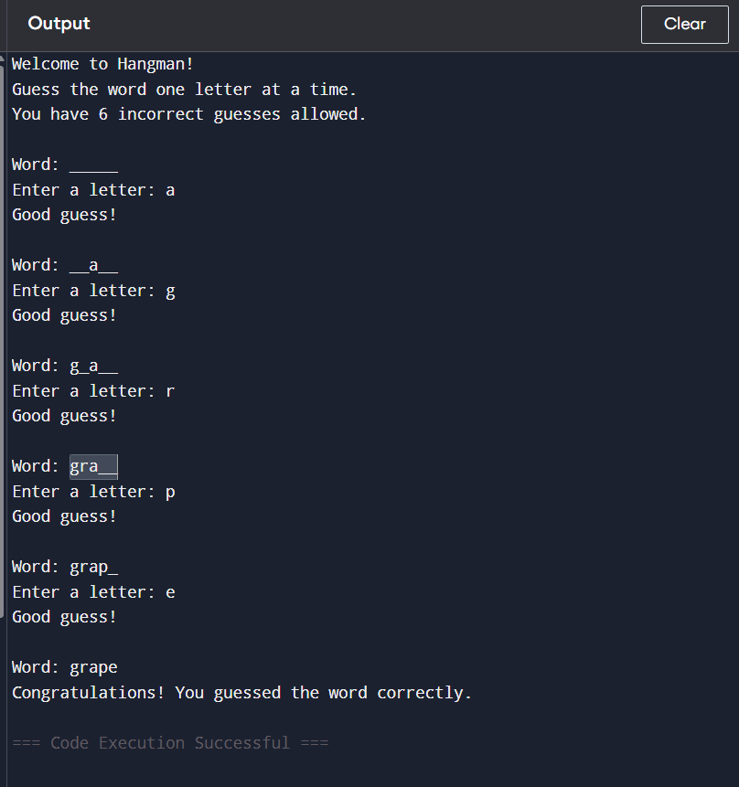

**Explanation:**

* Uses a predefined list of 5 words.
* Limits incorrect guesses to 6.
* Uses basic console input/output (**input()** and **print()**).
* Employs **random.choice()** to select the word.
* Uses a **while** loop to handle the gameplay.
* Implements **if-else** logic to handle guesses.
* Uses strings and lists to manage the display and tracking progress.